STAT Lab1

Problem 1.

1. 
2. 

Problem 2.

1. 
2. Stem-and-Leaf Display: Rate

Stem-and-leaf of Rate N = 50

Leaf Unit = 0.10

1 3 3

5 3 5679

10 4 01224

21 4 56666778999

25 5 0134

25 5 56889

20 6 0234

16 6 55566899

8 7 134

5 7 677

2 8

2 8 59

Problem 3.



Problem 4.

(a) Mean is 48.25, standard deviation is 40.24.

(b) Minimum Q1 Median Q3 Maximum

2.00 21.40 37.80 60.75 204.90

(c) 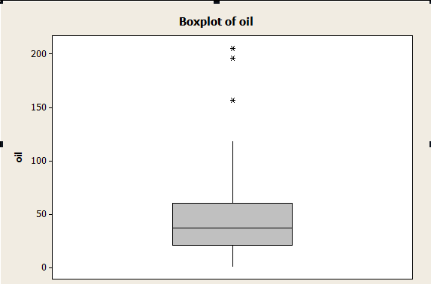

(d) value of IQR is 39.35.

According to the 1.5*IQR rule, the outlier has to greater than (1.5*IQR + Q3) or less than (Q1 - 1.5*IQR). In this case, outliers will greater than 119.775 or less than -37.625. The values of three outliers are 156.5, 196.0, 204.9.

Problem 5.

1. 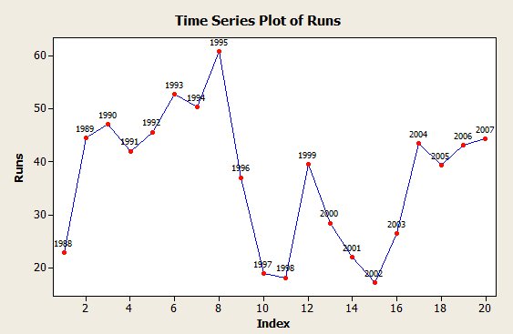

This time series plot shows us that the salmon run size was increasing between 1989 and 1995. At 1995, it reached the peak value of the run size. Decreasing between 1999 and 2002, then increasing until 2007.

There is a jump of increasing between 1988 and 1989. But the run size suddenly decreased since 1995(something big must happened), after 2 years, it went stable for 1 year. From 1999 to 2002, business went bad, and at 2002, it reached the bottom. Then they must did some changing, which made the run size goes back.

(b) 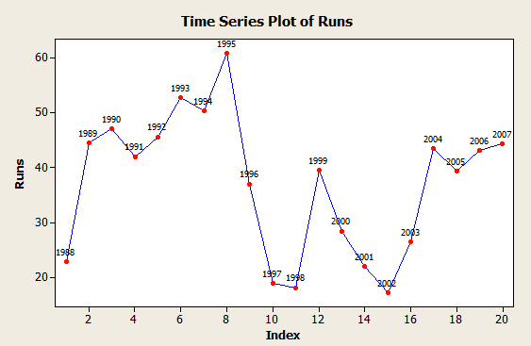

Problem 6.

1. The mean of GDPGrowth is 5.616%, and the standard deviation is 3.442%.
2. Azerbaij and Zimbabwe.
3. The mean after delete two outliers is 5.499%, the standard deviation is 2.319%.

Because these outliers are one maximum value and one minimum value, so delete them did not affect the mean too much. On the other hand, the new deviation shrink because two outliers are gone.

Problem 7.

Median is 5.5%, Q1 is 4% and Q3 is 6.9%. After deleted the two outliers. Median is 5.5%, Q1 is 4% and Q3 is 6.9%.

The median, Q1 and Q3 did not change because theses three value only determined by their position in the data. We eliminate the maximum and minimum does not affect their reference location in the whole data.

|  |  |  |
| --- | --- | --- |
| Set | Mean | Standard Deviation |
| A | 7.501 | 2.032 |
| B | 7.501 | 2.031 |

Problem 8.

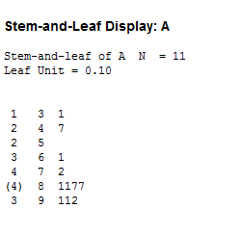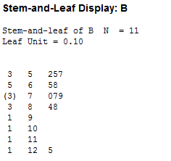

They have different distribution.

Problem 9.

(a)

|  |  |  |  |  |  |
| --- | --- | --- | --- | --- | --- |
| Ration | Minimum | Q1 | Median | Q3 | Maximum |
| New | 318.00 | 379.25 | 406.50 | 429.25 | 477.00 |
| Normal | 272.00 | 333.00 | 358.00 | 401.30 | 462.00 |

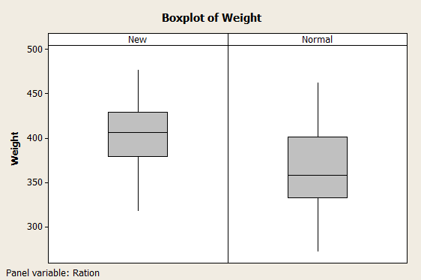

The five-number summary and the boxplot showed us that the new corn is obviously better than the normal corn. The weight of chicks that fed by new corns is more stable (we can see that easily from the boxplot). The other four values in five-number summary are also shows that the new one’s weight is much heavier than the normal, no matter the average weight or the extreme weights.

(b)

|  |  |  |
| --- | --- | --- |
| Ration | Mean | StDev |
| New | 402.95 | 42.73 |
| Normal | 366.30 | 50.80 |

402.95 – 366.30 = 36.65

The mean weight gain of chicks fed the new corn is 36.65 grams larger.